ALFRED AND LOUISE POWELL
by Dr. Kathy Talbot
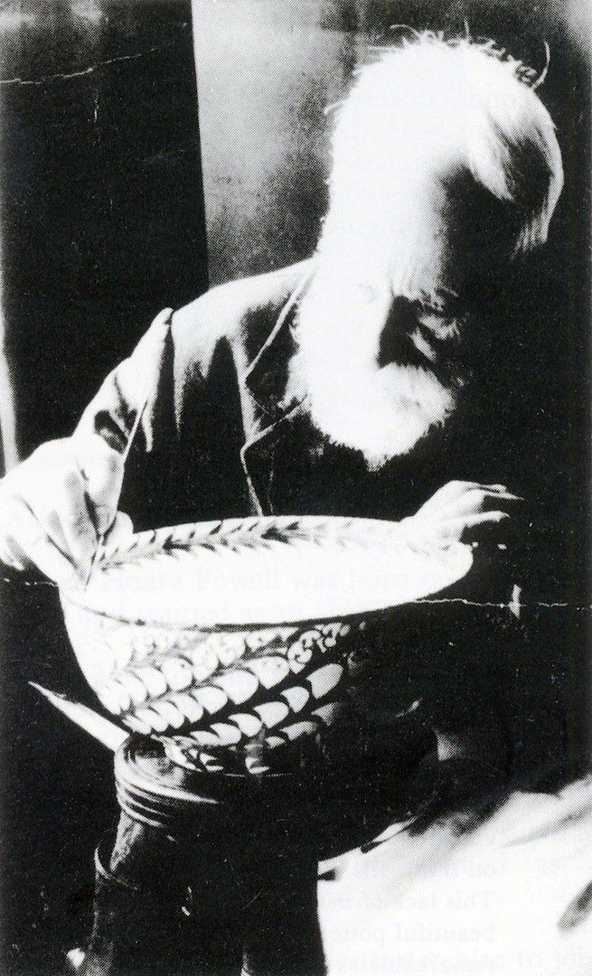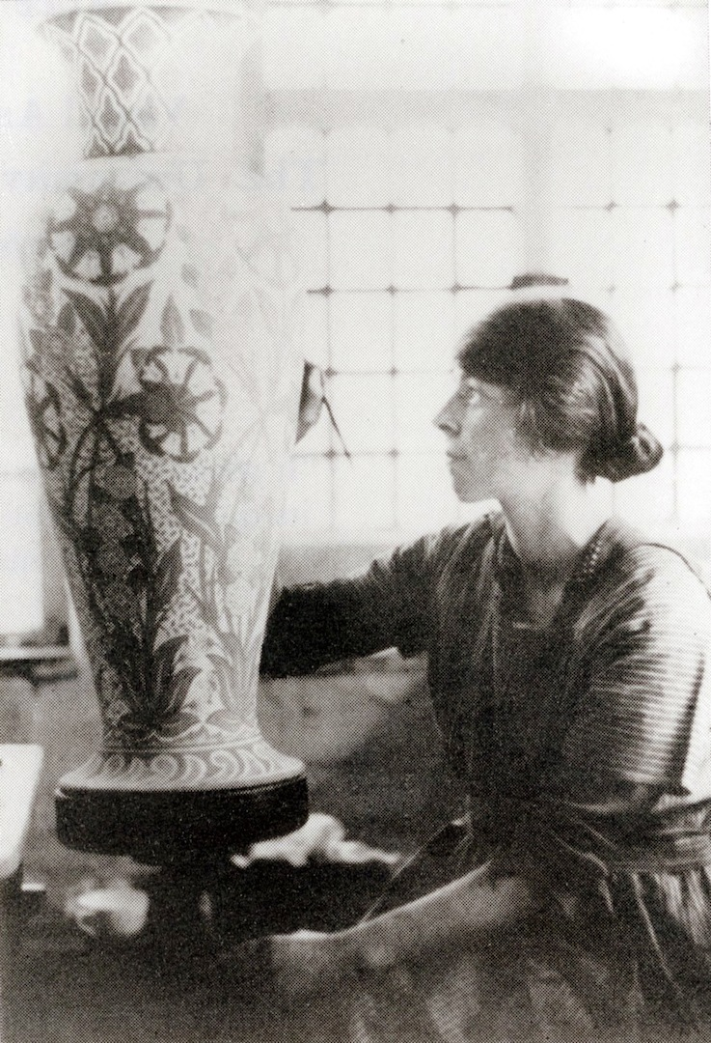

When Alfred and Louise Powell married in 1906 they both had established individual careers in fields other than ceramics, but in working together at Wedgwood they brought these differing skills to the successful revival of Wedgwood’s profile and fortunes.

Alfred Powell trained as an architect and, along with his colleagues Ernest Gimson and W.R. Lethaby, admired the writings of John Ruskin and William Morris. As an adherent to the Arts and Crafts Movement Alfred became skilled as a carpenter, but until his introduction to Wedgwood had had no experience in ceramics production in either a workshop or industrial context. Following the Morrisian belief that designers should understand the mechanics and production processes of the material for which they were designing Alfred Powell spent time at Wedgwood’s factory observing and learning throwing, moulding and decorating techniques. The Powells’ personal decorating work was done using Wedgwood ‘blanks’ at both Etruria and the studio established for them by Wedgwood in Red Lion Square, London

Louise Lessore trained at the Central School of Arts and Crafts where W.R. Lethaby was a Principal. She studied calligraphy and illumination and continued this work throughout her life. The School also introduced her to new making techniques and methods that could be used in large industrial trades. Louise’s grandfather, Emile Lessore, had been a celebrated ceramic decorator at Wedgwood and her father was a respected artist.

In 1903 Frank Wedgwood asked W.R. Lethaby to seek out a ‘modern’ designer for factory production. Lethaby contacted Alfred Powell who in due course submitted designs which were accepted. This occurred some three years before the Powell’s marriage and it is not known if Louise’s family connections were of any influence. The Powells advised and designed for Wedgwood for over 30 years and hoped to bring to the industrial environment some of the small workshop practices and individuality found in the principles of the Arts and Crafts Movement,
“a perfect union of good workmanship with happy thought”. It was to prove difficult to incorporate these ideals in industrial scale ceramic manufacture and to provide an environment for individual expression in the work of the paintresses.

Evidence of Alfred Powell’s design work at Wedgwood is very limited as few of the designs have any attribution and there are none with Louise Powell’s attribution, except for one very plain flat colour design in the Wedgwood Museum archive, (Pattern W4145, Harlequin). Alfred Powell created contemporary designs capable of repetition on the large dinner and tea services produced by Wedgwood. Louise Powell is credited with reintroducing the eighteenth century designs. She was possibly directed or drawn to the designs because their fine lines, delicate strokes and accuracy reflected her training in calligraphy. They required very deft handling of the enamel colours. None of the eighteenth century style designs show any author’s mark, but the Powells worked together on designs. Although Alfred Powell’s intention was to relieve the paintresses of repetitive, unimaginative work, he himself complained of the ‘drudgery’ of outlining in the execution of these designs. The early designs at Wedgwood, according to history, were those presented by Alfred Powell, and some early reports of the work credit him with the entire production. However, it can be argued that the examples of work reviewed in The Art Journal in 1905 which included a porcelain coffee service with “small freshly coloured posies and sprays” as well as a jug with lustre decoration are work by Louise Lessore. A lustre jug, with Louise Powell’s monogram, similarly decorated is in the Ceramic Collection (C315).

Her obituary describes her as “shy, quiet and softly spoken” and we have no writing by herself about her own work. However, recognition of Louise Powell’s work, as distinct from that of her husband, and the contribution she made to Wedgwood were clearly acknowledged and insisted upon by her husband. In a letter of 1921 to the Victoria and Albert Museum Alfred Powell is adamant that Louise’s work and identity should be clearly documented. He wrote regarding the labelling of items in their collection that “Mrs Powell’s full name to be given, viz. Mrs Louise Powell not Mrs Alfred Powell.” In a post-script he added “The ordinary title we use is as given AH and LP but if you have to mention Mrs Powell then it is Mrs Louise Powell.” “A.H. and L. Powell” was used in Alfred Powell’s article in The Studio in 1929. The Wedgwood factory continued to use Louise Powell’s maiden name and in Alfred Powell’s obituary in the company’s house magazine, Wedgwood Review, she is referred to as “his wife, Louise Lessore” and it also notes her relationship to Emile Lessore, demonstrating the significance of the family association to the pottery.

It is interesting to observe that although Louise Powell was a skilled calligrapher, those items in the collection with alphabetical characters were painted by Alfred Powell. (c319 and c320)

Alfred Powell was to describe his wife’s work in 1952. He wrote to a friend, “I’ve been thinking about the vast amount of work she has done, and so well done – we are near our 6000th pot and she was always quicker than I a-doing! And then the embroidery – flower painting – illumination – a lot of work and all, as I have seen it, done right at the beginning and never altered and very beautiful”

Louise died in 1956 and her obituary in The Times focuses on her skill as an illuminator and refers briefly to her work with ceramics; “the hundreds of pots painted in lustre and colour by her and her husband, which are treasured in English homes.” It does not mention any connection with Wedgwood. In contrast Alfred Powell’s obituary headed ‘Decorator of Pottery” states that he is best known “as a decorator in collaboration with his wife of Wedgwood pottery” discussing briefly his association with “a minor revolution” in architecture in using the building crafts as inspiration for their designs, following the Arts and Crafts Movement before describing in depth his work with Wedgwood.

At the turn of the twentieth century women were beginning to enter the field of work on their own behalf, but were often subsumed in their husband’s identity. Although Louise Lessore was already known as a skilled illuminator and calligrapher there is no occupation shown on the Powells’ 1906 marriage certificate. At Wedgwood the Powells maintained their own individuality both in the nature of their work and the recognition of it. Where they did work together was in the training of the Wedgwood paintresses and it was this initiative, hoping to bring personal satisfaction to the paintresses, which had the long lasting effect at Wedgwood.

Bibliography

Batkin, M. (1992). Exhibition catalogue:Good Workmanship with Happy Thought: The work of Alfred and Louise Powell. Cheltenham, Cheltenham Art Gallery and Museum.
Carruthers, A. and M. Greenstead, Eds. (1999). Simplicity or Splendour, Arts & Crafts Living: Objects form the Cheltenham Collections. Cheltenham, Cheltenham Art Gallery and Museums.
Powell, A. (1929). "New Wedgwood Pottery." The Studio 98: 875-880.
Powell, A. H. (1921). Letter to Smith, 30th December 1921, Victoria and Albert Museum.
Lethaby, W.R., A. H. Powell, et al., Eds. (1924). Ernest Gimson, his life and work. London, Shakespeare Head Press.
“Art Handiwork” Art Journal (1905)

Batkin, M. (1992). Good Workmanship with Happy Thought: The work of Alfred and Louise Powell. Exhibition Catalogue Cheltenham Art Gallery and Museum. p 16.
W.R., Lethaby., A. H. Powell, et al., Eds. (1924). Ernest Gimson, his life and work. London, Shakespeare Head Press
Batkin, M. (1992). Good Workmanship with Happy Thought: The work of Alfred and Louise Powell. Exhibition Catalogue Cheltenham Art Gallery and Museum p 17
Ibid p 15
“Art Handiwork”, Art Journal 1905 p 381
Powell, A. H. (1921). Letter to Smith, 30th December 1921, Victoria and Albert Museum. Victoria and Albert Ceramic collection
Wedgwood Review, Vol 1, no 12, (1960) Alfred Powell’s obituary was written by Norman Wilson, Works Manager at Wedgwood from 1927. He would have been well acquainted with both Powells.
Carruthers, A. and M. Greenstead, Eds. (1999). Simplicity or Splendour, Arts & Crafts Living: Objects form the Cheltenham Collections. Cheltenham, Cheltenham Art Gallery and Museums. 116

